TERM PROJECT FINAL REPORT
INFO 5707 - DATA MODELLING FOR INFORMATION PROFESSIONALS
GROUP 19
TITLE: THE DATABASE OF GAME LEADERBOARD

GROUP MEMBERS:
Lavanya Nidamanuri – 11747561
Kruthi Reddy Kasarla – 11749593
Shamitha Reddy Cheedu – 11751208
Archana Cherka – 11710337
Nisha Deepthi Perumalla – 11618009
SCOPE
A complete database system for a gaming leaderboard is part of the project's scope, and it will be created through design and development. To do this, it is required to list the supported games, describe player metrics, allow for real-time updates, integrate multiplayer features, create user profiles and achievements, make sure privacy settings and security protocols are followed, scale the system for ease of use, add a notification system, and offer analytics for deeper understanding. Providing a dynamic and interesting leaderboard system is the goal to showcase player achievements, promote community engagement, and guarantee a fair and secure gaming environment.
Moreover, it comprises:
PARTICIPANTS
Information regarding registering.
Specifics related to verification.
Details regarding previous performances
PUBG
Details regarding each game that is available on the platform.
Dates of publication.
Additional information regarding the game.
SCORES
Individual score entries pertaining to certain players and games.
The dates on which the scores were achieved.
LEADERBOARDS
Player rankings throughout all games as well as individual games.
leaderboards based on the different time periods shown.
PROTECTION
User authentication for access control.
Safeguarding the confidentiality and integrity of information.
Adaptability
Able to handle an increasing number of users and game-related data volumes.
THE GAMING LEADERBOARD DATABASE'S GOALS
i. Keep Track of Player Data:
Calculate how many people have signed onto the gaming platform. Keep track of any crucial player data, such as their email address, login credentials, registration date, and any other pertinent details.
ii. Monitor Game Details:
Keep track of the game data that is played on the platform. Include details like the game's title, the release date, and possibly some further information.
iii. Keep track of player scores:
Keep track of the points that players have accrued throughout different games. Assign each score entry to a certain player and game.
iv. Determine Rankings:
Player scores are used to establish and maintain standings. Decide on a system for determining the top players in each game. Permit the customization of ranking algorithms based on factors like time, score, or game complexity.
v. Leaderboards on Display:
Show the leaderboards for every game or all the games. Let users peruse leaderboards based on several parameters (daily, weekly, monthly, etc.). Display player usernames, scores, and maybe other relevant information.
vi. Security and User Authentication:
To provide secure database access, enable user authentication. Set and enforce the proper authorization levels to control who can change player information, game details, and scores.
vii. The third factor is scalability.
Create a database system that can accommodate an increasing number of users, games, and scores. As the dataset grows, maintain performance by optimizing queries and database structure.
viii. Accurate Data
The use of user authentication ensures secure database access. Ensure that the right authorization levels are maintained to control who has access to player, game, and score data.
ix. Auditing and Logging:
Maintain a database activity log for the purposes of debugging and auditing. Keep track of any modifications to the player, game, and score information.
x. Analytics Data Retrieval:
To help administrators and game developers better understand player behavior and trends, enable data retrieval for analytics.
USER REQUIREMENTS
i. User Registration:
The system should allow players to register accounts, providing essential information like a username and email.
ii. Score Report Submission:
Gamer’s ought to be able to enter their scores for different games, and the system ought to keep track of the score, the corresponding player, and the game.
iii. Leaderboard Accessibility:
Leaderboards for individual games and overall rankings should be easily accessible to users, who may be spectators as well as players.
IV. History of the Score:
It should be possible for players to see their past performance and scores throughout time.
v. Game Specific Information:
Information about the games that are available, including their titles and releases, should be accessible to users.

vi. Transparency in the Ranking Calculation:
To ensure fairness and user understanding, the system should openly explain how player rankings are determined.
vii. Customizing the Leaderboard:
It's possible for users to modify leaderboard views according to additional parameters or time periods (daily, weekly, or monthly).
viii: Security and Privacy
Make sure user privacy is preserved and data is protected. Safe authentication procedures and safeguards against unwanted access are part of this.
ix. Notification Mechanism:
Establish a notification system to inform players when important things happen in the game, such as reaching a high level or winning prizes.
BUSINESS RULES
The regulations that the system abides by are listed below:

i. To ensure accurate identification and prevent miscommunication, each participant must have a unique login.
ii. Scores provided by players must be precise and follow the rules and gameplay features of the games in question.
iii. Prior to accessing and utilizing the gaming leaderboard system, users must authenticate themselves.
iv. Ensure openness and fairness; player rankings must be established using a consistent hierarchy.
v. Update the player database; inactive user accounts may be removed after a set amount of time.
vi. It's critical to keep accurate and up-to-date information about games, including release dates.
vii. Certain system functions, such as administrative tools, should only be accessible to authorized staff members.
viii. The system must comply with data privacy rules in order to maintain confidence and protect user information.
ix. It is important to implement anti-cheating measures that detect and halt system abuse to guarantee fair competition among players.
x. Decide how frequently the leaderboards should be refreshed to ensure that the most recent scores and ranks are shown.
xi. Create policies for alerting users to significant events so that there is consistency and no possibility of spamming.

ENTITY-RELATIONSHIP DIAGRAM OF THE DATABASE OF GAME LEADERBOARD:
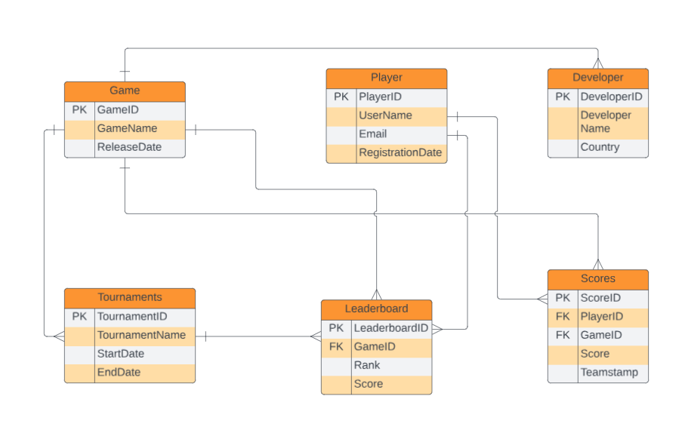

DATA DICTIONARY FOR THE DATABASE OF GAME LEADERBOARD

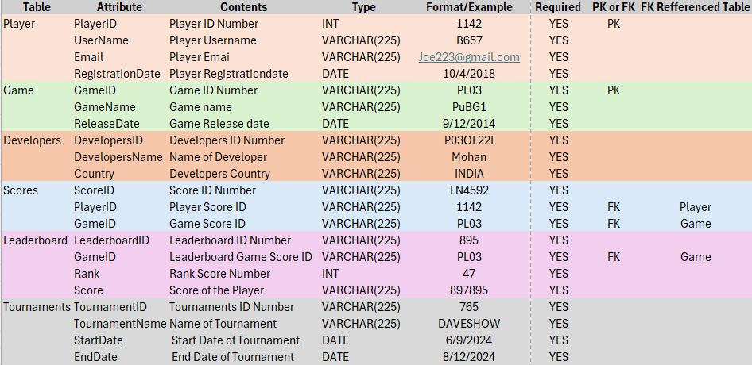

CREATE DATABASE
Query: Create database project_gaming_leaderboard;
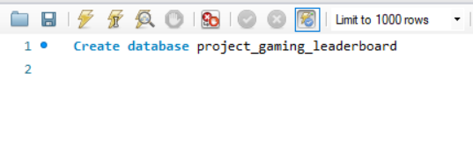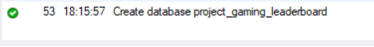

USE DATABASE
Query: Use project_gaming_leaderboard;
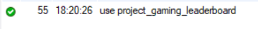
DATA ENTRY AND UPDATE
- Player Table
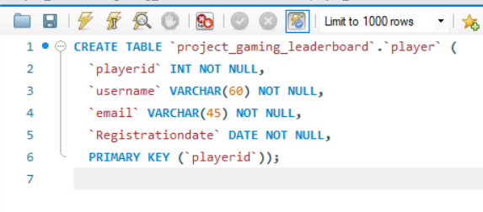

ALTER TABLE
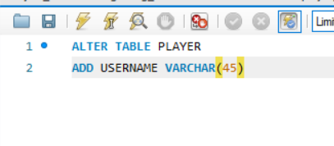

INSERTING VALUES
We have inserted all 25 values with the below code.
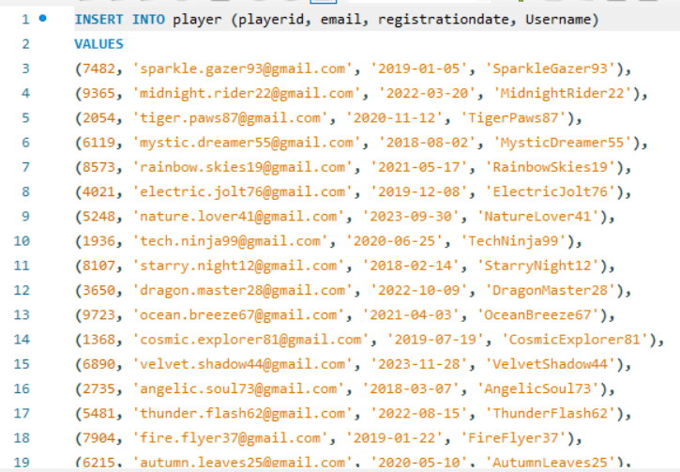

DATA RETRIEVAL:

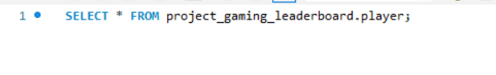
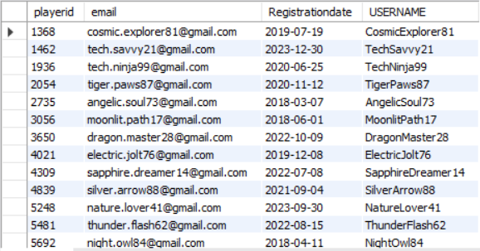

- GAME TABLE
CREATING TABLE
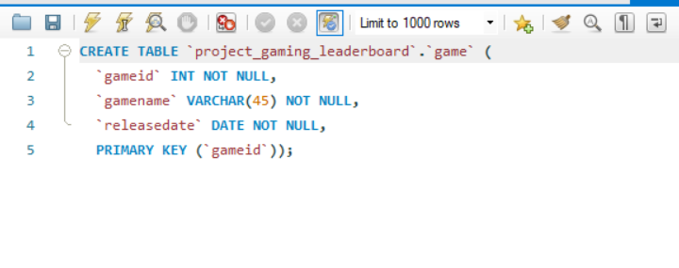
INSERTING VALUES
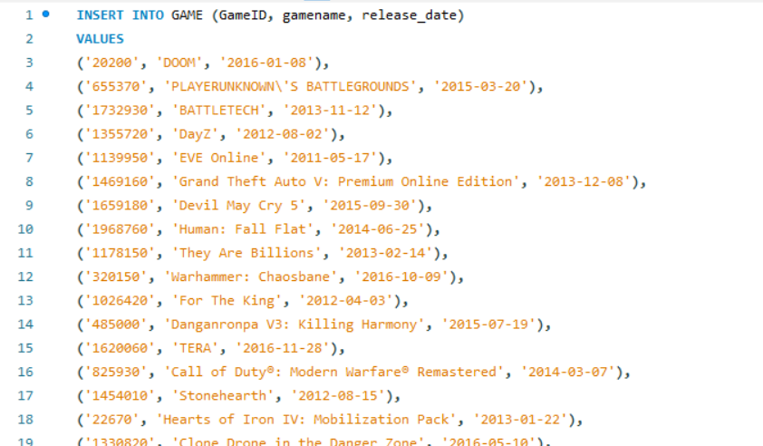
ALTER TABLE
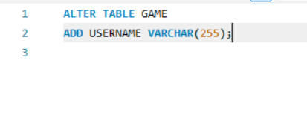

DATA RETRIVAL:
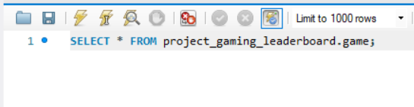
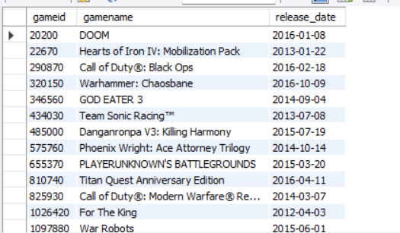

- DEVELOPER TABLE
CREATING TABLE:
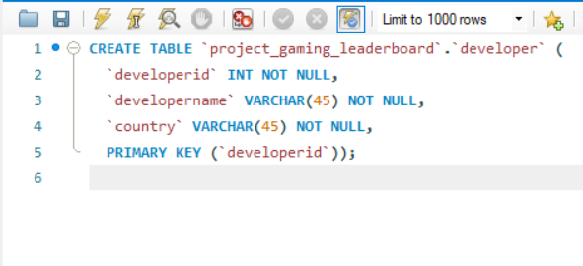
ALTERING TABLE:
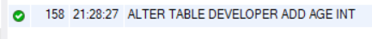
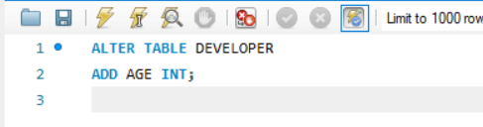
INSERTING DATA
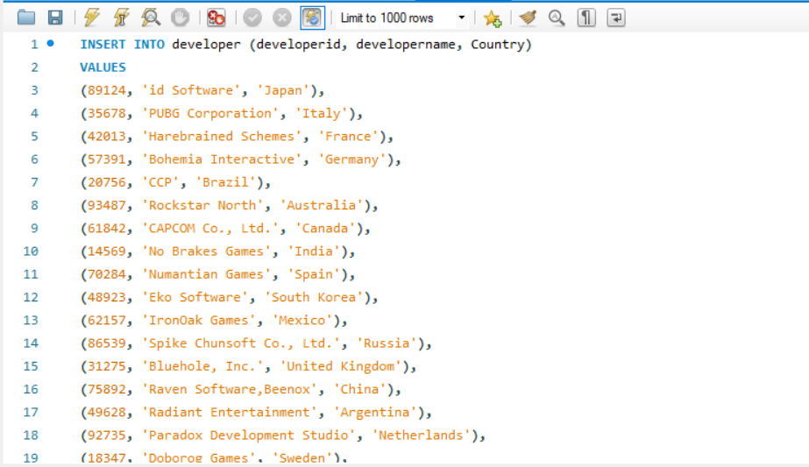
DATA RETRIVAL:
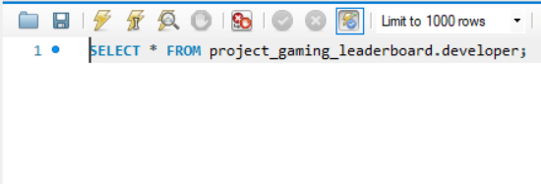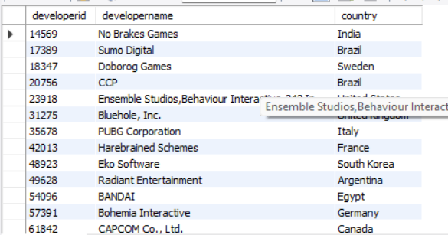
- TOURNAMENTS
CREATING TABLE
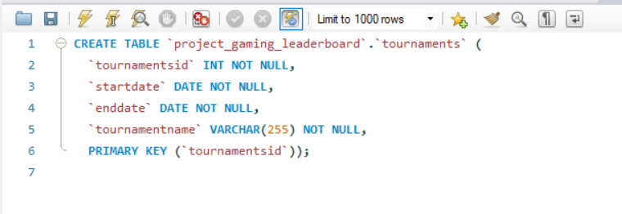
ALTER TABLE
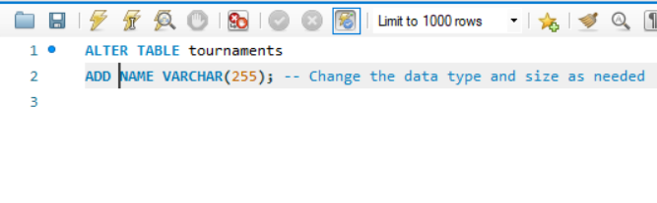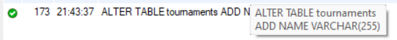
INSERTING
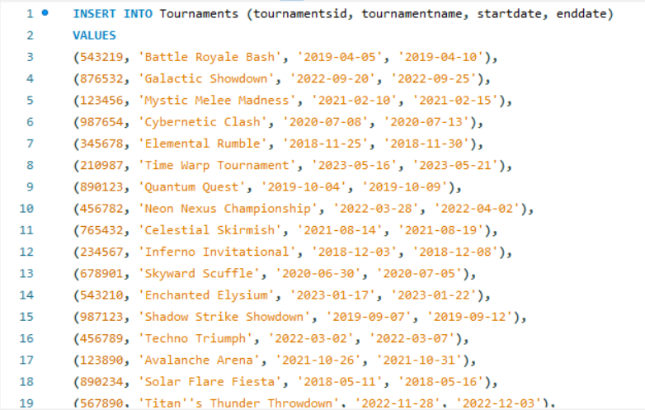
DATA RETRIVAL:
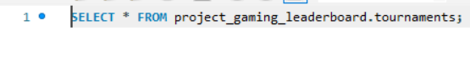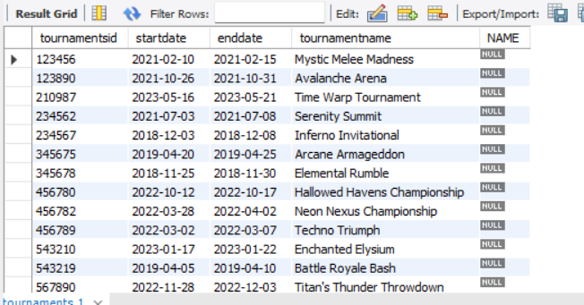
- SCORE
CREATING TABLE
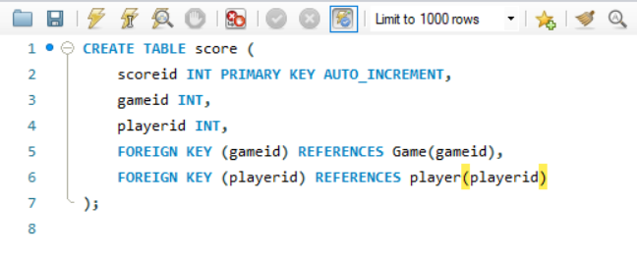
ALTER TABLE
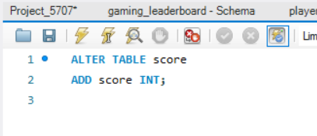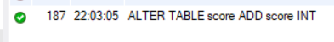
INSERTING TABLE
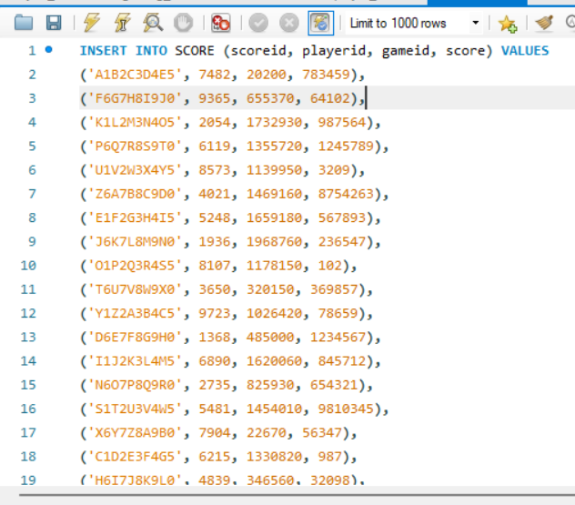
DATA RETRIVAL
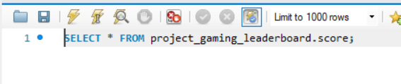
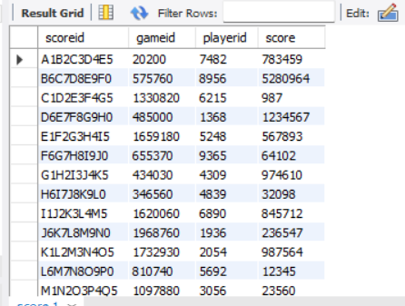
- LEADERBOARD
CREATING TABLE
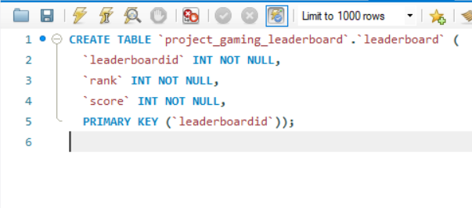
ALTER TABLE
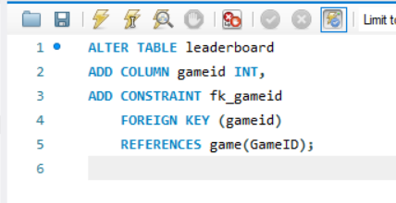
INSERTING VALUES
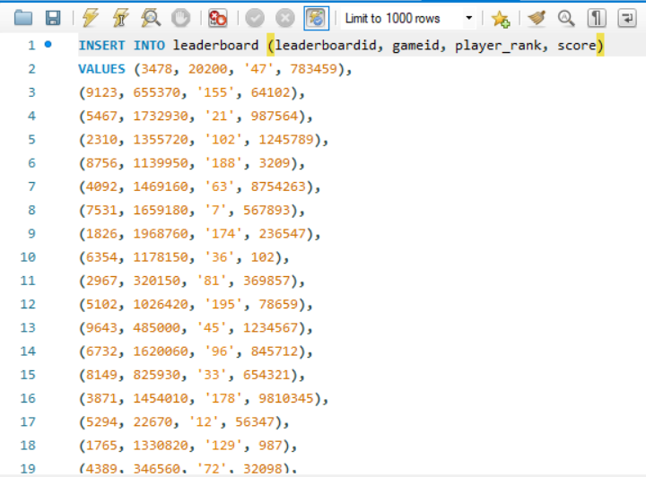
DATA RETRIVAL:
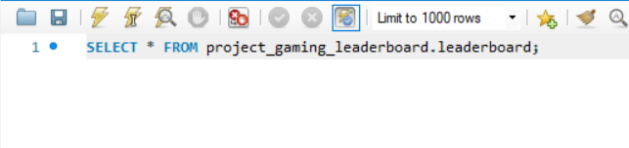
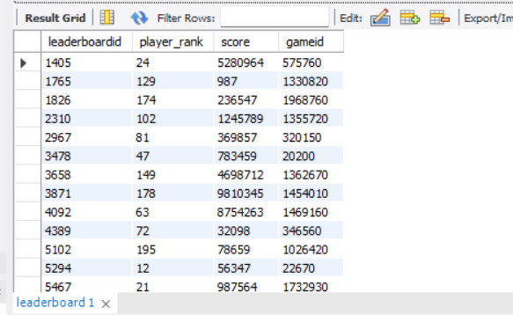

QUESTIONS
- Display the GameID and Game Name where the first letter of the game name is 'C', you can use a SQL query.
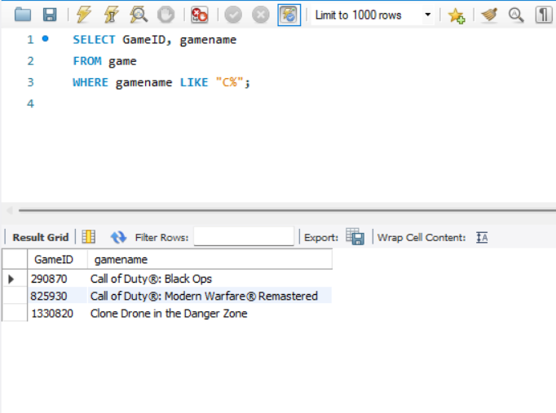

- Games released after July 1, 2015, as well as usernames of players playing games with the letter 'C' in the name
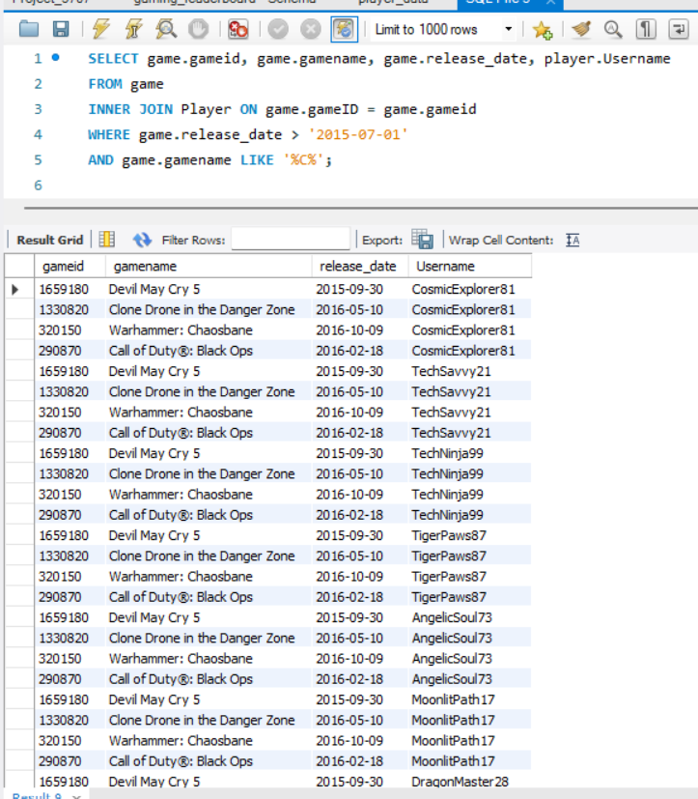

- What are the top 5 developers by the count of distinct games they have developed, listed in descending order
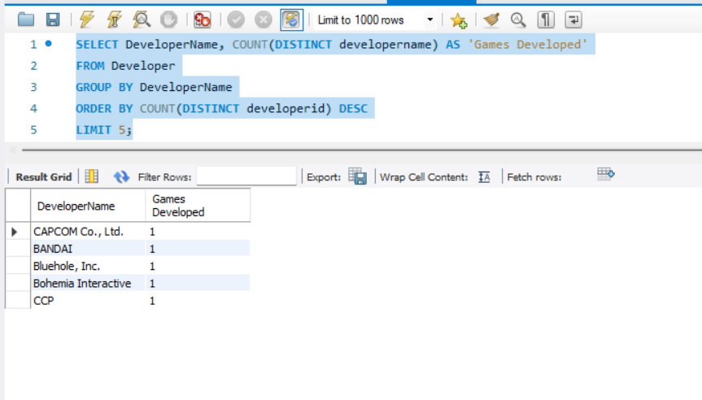

- What is the average player rank per month and year of game release across the dataset, displayed by release year and month?
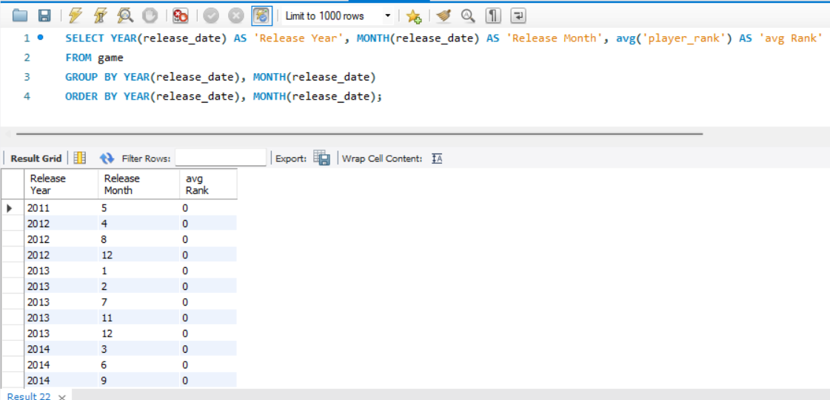

- What is the highest score achieved in leaderboard. Display highest score and leaderboard ID from different tournaments?

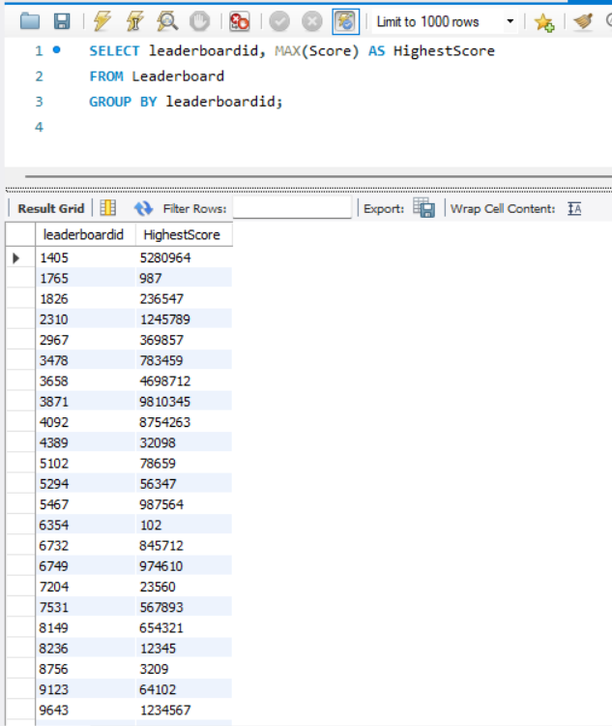

- Which developers have created games with the highest average scores?

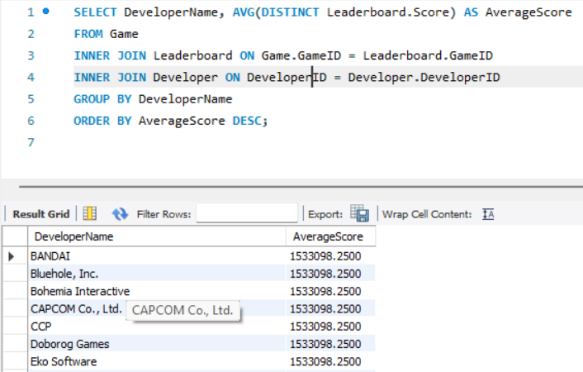

- Which players have participated in the most tournaments?
Here we didn’t get any info in output since we don’t have players in common in different tournaments.
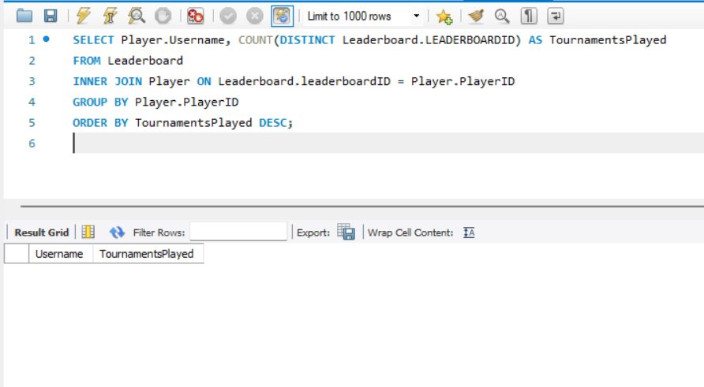

- which country developer has ranks below 10. provide the Developer name ,country?

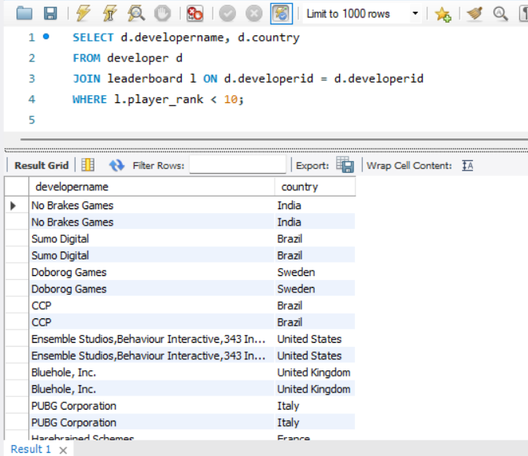

- Which developer country has leaderboard scores more than the average of all leaderboard scores, provide game name and developer country and leaderboard score?
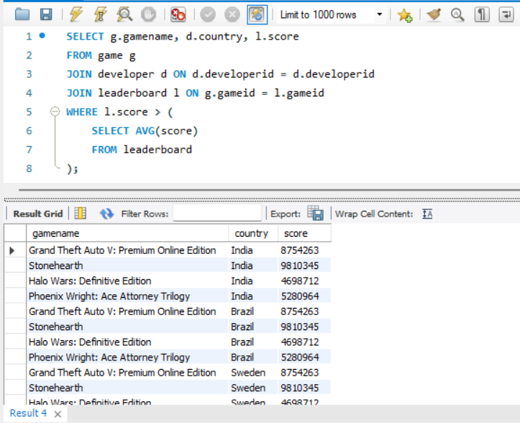
DBMS in terms of selection:

The database management system that will be utilized for our project is MySQL. MySQL is a popular database management system (DBMS) for online applications, available under an open-source license. This database system can accommodate many users concurrently, in addition to being scalable and long-lasting. MySQL packages additionally offer tools for data protection, data management, and data analysis. It is simple to integrate with a web-based application because it works with a variety of programming languages and frameworks.

In summary:

The goal of the game leaderboard database project was accomplished, resulting in the creation of an incredibly accurate and thorough database with gaming leaderboard data. The database's simple interface and low maintenance requirements make it an invaluable tool for both game developers and players.

The database utilizes a normalized schema to guarantee data accuracy and is efficiently structured. Because the tables are connected by suitable foreign key restrictions, the data is efficiently organized and easy to access. The data also shows a high level of organization.

In addition, the project has included a number of useful features, one of which is the capacity to determine individual average scores for each developer. Through the use of this feature, gamers can compare the effectiveness of games from different producers. Finding out which developers are the most skilled in the field may be possible with the help of this data.

When everything is considered, the gaming leaderboard database project is a very well-thought-out and significant addition to the gaming community. It offers a gaming leaderboard statistics database that is easy to use and maintain, in addition to being thorough and accurate.

